Name: D.Darshan Course code:DSA0602
Reg no:192524117

Unit 2 Class Activity 1: 20.07.2026

1. Hospital Patient Admission Analysis
A hospital has collected data on patient admissions across multiple departments (Cardiology, Neurology, Pediatrics, Orthopedics, Emergency) for the past year. Different visualizations (bar chart, stacked bar chart, treemap, box plot, histogram) are available. Evaluate which visualization most effectively communicates department workload, admission variability, and patient distribution. Justify your selection with evidence.

Python code:
import pandas as pd
import matplotlib.pyplot as plt

# Read the CSV file
df = pd.read_csv("hospital_patient_admission.csv")

# Display first 5 records
print(df.head())

# Bar Chart - Patients by Department
df["Department"].value_counts().plot(kind="bar")
plt.title("Patients by Department")
plt.xlabel("Department")
plt.ylabel("Number of Patients")
plt.show()

# Histogram - Length of Stay
plt.hist(df["Length_of_Stay"], bins=5, edgecolor="black")
plt.title("Length of Stay")
plt.xlabel("Days")
plt.ylabel("Patients")
plt.show()

# Box Plot - Age
plt.boxplot(df["Age"])
plt.title("Patient Age")
plt.ylabel("Age")
plt.show()

# Analysis
print("\nAverage Age:", df["Age"].mean())
print("Average Length of Stay:", df["Length_of_Stay"].mean())

Output:
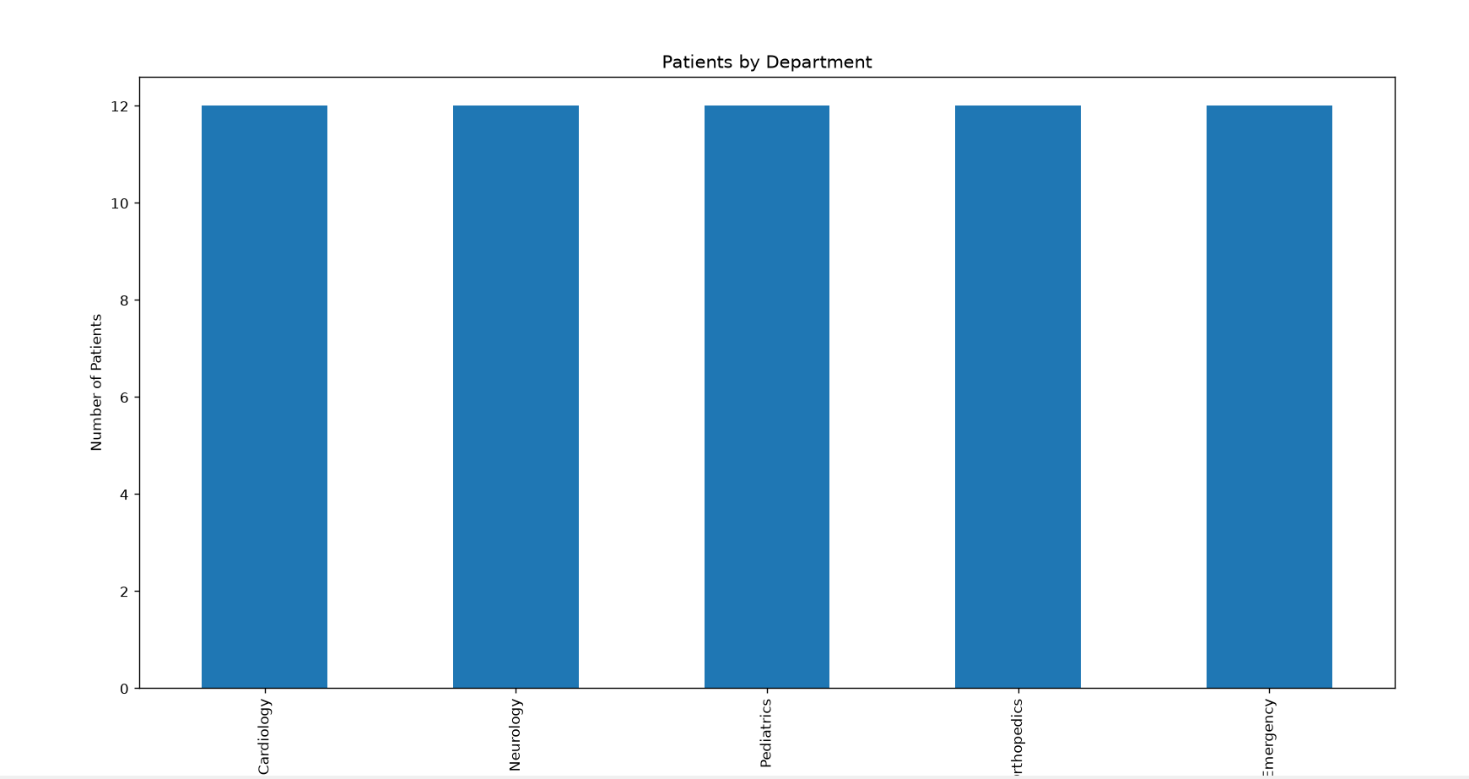

2. E-Commerce Customer Spending Behaviour
An online retailer has customer purchase amounts, order frequency, and product categories. Create multiple visualizations (histogram, violin plot, box plot, density plot, bar chart). Evaluate which visualization best identifies high-value customers, spending variability, and purchasing trends. Recommend the most appropriate visualization for business executives and explain why.
Python code:
import pandas as pd
import matplotlib.pyplot as plt

df = pd.read_csv("ecommerce_customer_spending.csv")

print(df.head())

df["Category"].value_counts().plot(kind="bar")
plt.title("Product Categories")
plt.show()

plt.hist(df["Amount_Spent"], bins=5, edgecolor="black")
plt.title("Amount Spent")
plt.show()

plt.boxplot(df["Amount_Spent"])
plt.title("Amount Spent")
plt.show()

Output:
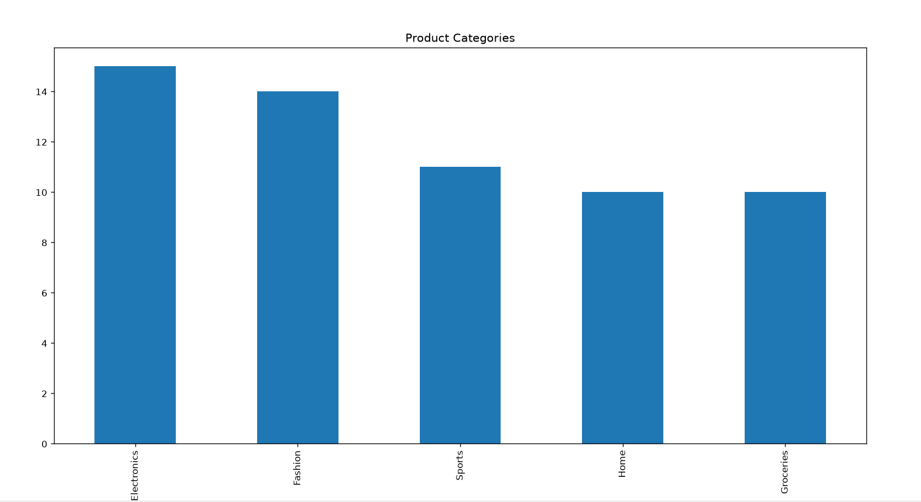

3. University Examination Performance Dashboard
A university wants to compare student marks across departments and identify score distributions, outliers, and top-performing classes. Generate different visualizations and evaluate which charts provide the clearest insights for academic decision-making. Recommend improvements to the visualization dashboard.
Python code:
import pandas as pd
import matplotlib.pyplot as plt

df = pd.read_csv("university_exam_performance.csv")

print(df.head())

df["Department"].value_counts().plot(kind="bar")
plt.title("Students by Department")
plt.show()

plt.hist(df["Final_Marks"], bins=5, edgecolor="black")
plt.title("Final Marks")
plt.show()

plt.boxplot(df["Final_Marks"])
plt.title("Final Marks")
plt.show()

Output:
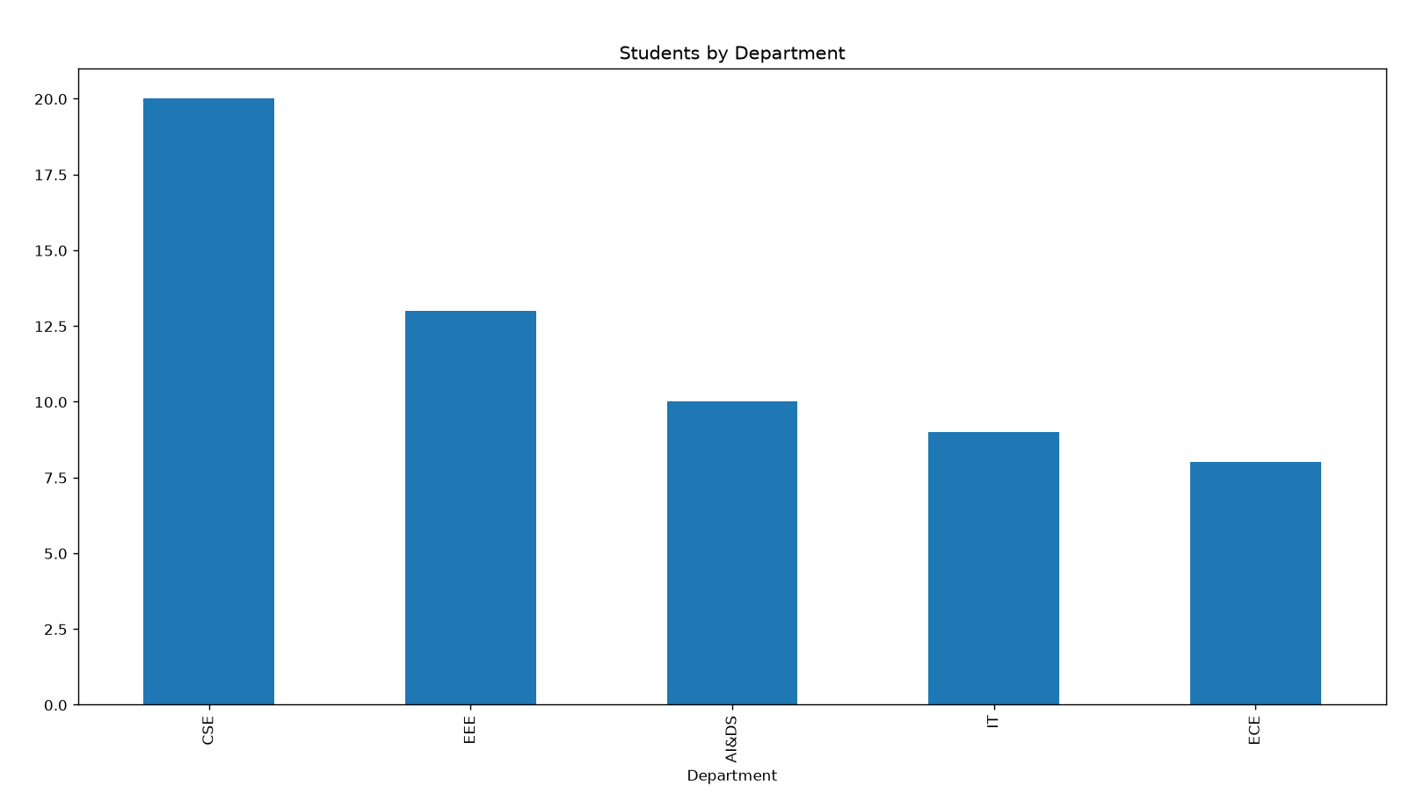

4. Climate and Rainfall Distribution Study
Meteorological data contains monthly rainfall, temperature, and humidity for multiple cities. Produce histograms, density plots, box plots, and bar charts. Evaluate which visualization best represents seasonal rainfall variation and climate distribution. Compare at least three visualizations and justify the most suitable one for environmental researchers.
Python code:
import pandas as pd
import matplotlib.pyplot as plt

df = pd.read_csv("climate_rainfall_distribution.csv")

print(df.head())

df.groupby("Month")["Rainfall_mm"].mean().plot(kind="bar")
plt.title("Average Rainfall")
plt.show()

plt.hist(df["Rainfall_mm"], bins=5, edgecolor="black")
plt.title("Rainfall")
plt.show()

plt.boxplot(df["Rainfall_mm"])
plt.title("Rainfall")
plt.show()

Output:
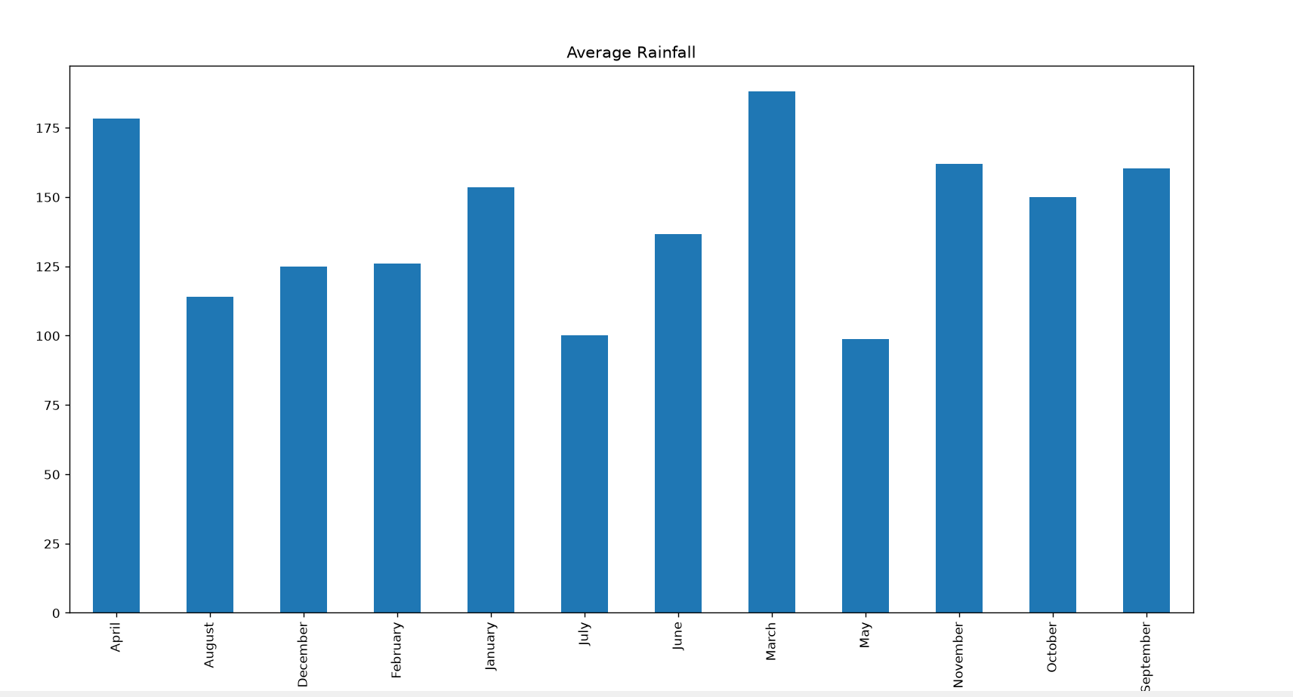

5. Bank Loan Risk Assessment
A financial institution has customer loan amounts, repayment history, income levels, and credit scores. Develop visualizations showing loan distributions and customer segments. Evaluate which visualization best supports loan approval decisions by highlighting risk patterns, skewness, and outliers. Recommend the visualization that should be included in a management dashboard.
Python code:
import pandas as pd
import matplotlib.pyplot as plt

df = pd.read_csv("bank_loan_risk.csv")

print(df.head())

df["Employment_Type"].value_counts().plot(kind="bar")
plt.title("Employment Type")
plt.show()

plt.hist(df["Credit_Score"], bins=5, edgecolor="black")
plt.title("Credit Score")
plt.show()

plt.boxplot(df["Loan_Amount"])
plt.title("Loan Amount")
plt.show()

Output:
